BY- NIHAR MORE April 27, 2015

TRAIL TO THE REALM OF TIME.
  - ON THE WAY OF TIME

CHARACTERS.
MARK SAMUEL -- AN UGLY SHY BOY
JULIE FLETCHER -- MARK’S GIRL FRIEND
MRS. SAMUEL – MARK’S MOTHER
RON -- SCHOOLMATE OF MARK
KING LOLITHON – GOD OF TIME
SAM KYLE – OLD JUNGLY MAN
PRIEST OF THE CHURCH
SAINT OF THE MOSQUE
QUEEN OF TIME
(TIME FORMAT – DAYS: HOURS: MINUTES: SECONDS)

PART I -- A NEW ILLEGAL ENTRY.
(A bright day, birds chirping, fishes swimming. There was a sudden knock on the door. “Knock knock knock”)
Who’s
There on the door couldn’t see I am bathing, Mark said. Mom just go and open the door and see who the hell is knocking so loudly. Yup son just reaching there, replied Mom.
(Door opens with a crack)
An ugly man with short red trousers and a big old fashioned hat was standing at the door. Mom soon recognized that it’s the postman and he had brought a letter for her son. Mark came out of the bathroom and went to is room where his mom was waiting with the letter. Son what’s this another love letter what the hell are you doing in the school, mom said. Mark was grief sticken for a while and then he replied that it was a letter from his old grandfather who has died years ago. Mark thought how this could happen. He bashed out of the house with his cycle and ride out to the post office.
(At the post office)
John jumped in front of a postman and asked about the letter. The man replied that they found the letter in the bundle of old letters and thus they mailed it to Mark’s house.
(Outside the post office)
Julie what are you doing here, said Mark. Your Mom had taken the home on head and she was in great anger and shouted me to go out and find you friend, replied Julie. Mark thought for a while and opened and read the letter. It spoke out about an era of time. “THE FUTURE IS HERE” said it. Mark also found a key and a map in the letter. Mark was totally in an adventurous mood. Without worrying about mom he with his girlfriend went on the path that the map told. It moved them throughout the jungle and at last the reached around an ancient decomposed house. Hey Mark just watch this machine, said Julie. Looks it works now also, said Mark. What are you doing Mark, said Julie. Just playing out and hunting for the right button to accelerate the machine, aha this one is right.
(Mark press the button and suddenly the land starts shaking and suddenly the machine blasts and a wholesome cloud of dust and smoke arises.)
What the hell is this now, says Mark. Julie just hold my hand I don’t know what’s going around here. Yaa Mark, replied Julie. I‘ll just remove my pocket fan out and just clear this thing off, said Mark. Ahaa thank god this shit is all away, says Julie. What the fish is this place??? , says Mark. Where are we?? Are we lost?? , said Julie. A strange voice replied, this is the world of time. “World of time” what’s this new shit whoever you are we just want to go home so just tell us the exit otherwise I have no time to bash on you, replied Mark.
(There was a sudden hard hit behind Mark’s and Julie’s head and they both fell unconscious on the land.)

PART II -- EXPLORING THE LAND OF TIME.
Whoa!
Where I am whose place is this, said Mark. Julie where are you. Hiee Mark, a voice replied from behind. Hey Ron what are you doing here, said Mark. I was following you and Julie, said Ron. Oh! Yup but where’s Julie. I don’t know I was also unconscious like both of you, said Ron. (A young old man appeared in front of them). She has came she has came, shouted the old man. Who the hell has come ???, said Mark. Queen of time, replied the man. Who is the queen of time, said Ron.
She is the mightiest of all the most powerful with the power of ravages of time. She has returned to kill and avenge her fierce death, said the old man. I think we must meet her, said Ron. No never I have to find my girlfriend and everyone would be worrying about me and her. Hey you old fellow please tell me where is my girlfriend and where’s the exit of this place, said Mark. There’s no exit you have travelled 100 million years into the future. Only if you have to return you must defeat king of time “KING LOLITHON”. King Lolithon what a lol name, said Ron laughing aloud. I want to save my girlfriend and return to my home you old sick person tell me where the shit is this Lolithon, said Mark angrily. No one knows where the King stays just everyone knows that he confides in the “Silence of noise” and “vicious of the blood dragons”. Silence of noise what’s this thing now, said Ron. I want to know more about this world, said Mark. (They both follow the old man in a haste. The man removed a book from the shelf and read it aloud.) This is a world build by the ravages of time. Everything here depends upon the heart clock situated in the middle of the town. As and when the time of the heart clock comes to an end this world destroys on its own. People here also live by time there wrist watches are their lives. Everything from opening of a door lock to funding salary to employees is based on time. Oh! What an ugly world, said Ron.
(Aaaaaa aloud noise comes from the mouth of the old man and a loud beep sound came from his hands. Beep beep beep it cried. Both Ron and Mark looked suspiciously at his hands. They viewed a watch in his hands a different one its mechanism was totally different than the normal ones. They both looked at the time it showed 00:00:00. Both of them got frightened a big blue beam of light came rapidly parallel towards them.)

PART III – ENRAGED BY A NEW LIFE.
(The boys were again unconscious and as and when they woke up they saw something mysterious and strange.)
Hey what the shit is this on my hand, said Mark. It’s something like the strange watch on the hands of the old man, said Ron. I must remove it out now but it’s got jammed on my hands I can’t remove it. (The place begin to again pulsate and eccentric declaration replied in a spiteful voice.) Hahaha I am the queen of time I will totally havoc both of your lives. We’ll totally wipe out you and your hubby, alleged Mark. We’ll definitely see what you petite ones can do to harm me, said the queen. So let’s start your phase from now.
(Both the watches started making enigmatic voices and the fingers of the clock started fluctuating rapidly. At a jiffy point it stopped and the time was……………………………….
29:696:41,760:25, 05,600)
Hey what’s this numbers??? , said Ron. Let me see hey its same on my clock too wait a min. Got it it’s based on the configuration of time i.e………………………………………………………….. “DAYS: HOURS: MINUTES: SECONDS”, said Mark. Ohh so the queen has given us 29 days and 696 hours and 41,760 minutes and 25, 05,600 seconds to destroy her and save ourselves or else………… ,said Mark. What else Mark say why are you serene, said Ron. Or else we’ll depart this life like the hoary man did. But from where must we start, said Mark.
(They both moved out of the house with the old man’s tome and a plot along them.)
This is really very strange why this queen or hell she is has given us the job to kill her selves. Why we have to enter into this shitty matter we just wanna go to our homes and take a short siesta. Ohh I am just entirely ravening not mice but dinosaurs are just dancing in my tummy, said Ron. Got it you are intellectual Ron, said Mark. Wow! Thanks but why??? , said Ron. You know the man told us about the vicious of the gore dragons. This is a futuristic world so all the mortals are reincarnated by time so we must look about for a place related to dragons or wild beasts. Let’s look in the map, here it is, said Mark. It’s the grotto of vestige quadrupeds we must look out there, said Mark.

Part IV -- Incoming into the prodigy of extra-terrestrials.
(Both of them move towards the cave of the E-T it was very dark cave besides a cascade)

Hey
What’s this new disaster now? Where are we this is such a black cave it’s very gloomy here, said Ron. Yup I have got some matchsticks and candles. Let me light them up, said Mark. Ohh looks that this is a timeworn cave lets go inside it. Ohhhhhhhhhhhhhhhh my gooooooood what the hell of shit is this blood and carcass of dead humans surround all over here, said Ron. Follow me we have no time else we’ll be one of them, said Mark.
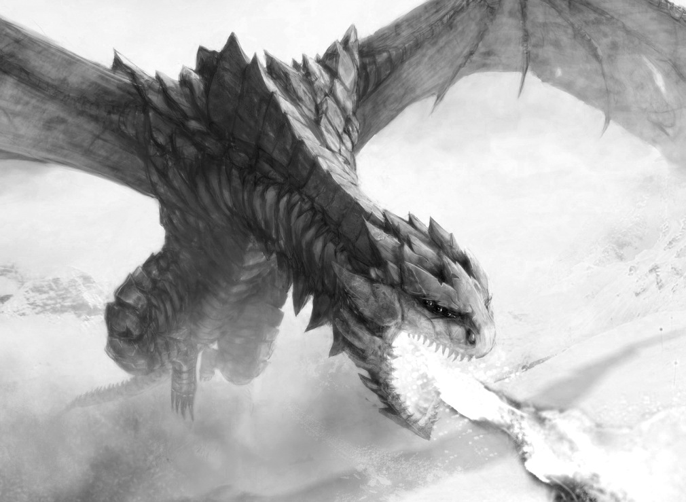
(There were some pictures of the creatures a loud roaring sound came from the outlet of the cave. The blood dragons were readily surveillancing at the two boys as their victim.)
(Time – 28:672:40,320:24, 19,200)
Hey Mark just look at that red one looking at me with great antagonism. Just coming about to make me his prey (The dragon comes near Ron and roars and he got’s terrified) Mom where are you please save me this creature will just scissor me out Susan where are you, cried Ron. Hey I think you were calling your mom from where Susan came in between she was your 7th Girl friend
I think so naa sorry the 8th one who passed away years ago aha she died while drinking milk, the buffalo fell on her yup I remember, said Mark. Leave it Mark what should we do now, said Ron frightenedly. Hmm let me look in the book it says that the blood dragons have a very poor visual guidance but they are strong at inferring so we must walk down slowly to that shrine we’ll get answers of our all questions there, said Mark. I don’t know anything Jesus just take me out of this contemptuous place, said Ron. (Both of them walked sluggishly towards the shrine but Ron gets another blunder by marching on the tails of one of the mortal and thus another shit takes place. The terrified beast notices and run towards them to pack up their lives)
(Time – 27.5:660:39,600:23, 76,000).

PART V -- DISCHARGE FROM THE FLESH BEHEMOTH’S.
Jesus
Please save me I am frustrated running from this wicked creature. Ron just shut your face and run we must reach that temple behind the old shards, said Mark. (One of the dragon came in front of their way and other from the back. Both of them poured out some mud over the eyes of the creatures and took a smack behind a big stone. Both of them planned how to teach a lesson to the creatures)
Hey!!!!! You big ugly slummy creatures I am gonna teach you a nice lesson just follow me, said Ron to quirk the attention of the creatures, Then he gave an precursor to Mark and ran away towards the ending of the cliff. Mark quick in a jiffy ran away into the old temple and began to hunt for any clues about King Lolithon. He hunted the whole temple but didn’t found any pinch of it at last he speckled a small holy bushy shrub at the admission of the shrine. He just quickly looked all over it but couldn’t find anything alas he saw something admirable hiding under the mud above which the shrub was planted. He quickly dug it out and saw it. It was an adornment with a sign on
it Mark looked at it for a while and thought
And ran away keeping it in his receptacle. (Here on the other hand Ron was really quiet busy with the annoyed creatures he was just at the dead end of the cliff and was a step behind to fall down.)
Ohh my god this is the last time I am talking to you please save me I am not married yet tell my mother that I love her a lot and also tell Susan that I had taken her $500. And also tell rosy that she was my last 11th girlfriend BYE BYE everyone, said Ron.
(Precipitously voice came from behind oye oye oo oo aaa ooho oo wholalala buumbaaa there was a man swinging with the sake of the branches of the tree’s and by mistake a branch broke and he directly fell giving a hard hit to the creature and as a result the creature fell down from the cliff. But the man also got a tight hard beat on his bum.)
(Time - 25.8:619.2:37,152:22, 29,120)

PART VI -- RESURRECTED INTO A NEW SAGACITY

(Mark was thinking and observing the little pendant while Ron was thanking the jungly person for saving his life. The Old jungly man in return stipulated to help them in their journey. Mark agreed and asked his name the man replied that his name was Sam Kyle.)
Back
To earth thank god I was just died but now regained into a new life, said Ron. Yaa you have to get into a new life, said Sam. What a new life??? Why??, said Mark. Not a new life but a new style, said Sam. What do you mean by a new style Sam? , said Ron. I mean the symbol in your hand it’s the holy pristine symbol of the churches and this one represents the St. Peterville’s church, said Sam. Ohh then our next destination is this church, said Mark. Yaa but before it you have to make some changes in your style you have to wear white dresses and …………… , said Sam. And what Sam please say, said Ron. And you have to eat pig and cows. What!!!!!! The **** it’s impossible I will not do this it’s a foul to my etiquette’s Mark we can’t do this shit, said Ron. Ron you won’t but I will no matter what I want to do I want to rescue my girlfriend let’s move on to the way if church.
(That Mark and Sam ate lots of flesh of cows and pigs and wore white dresses and went to the church while Ron was waiting outside…)
That’s the priest you could ask anything you want, said Sam. Holy sir may I know something about this pendant, said Mark. The priest replied in a very mysterious way, what it’s the sign of odyssey and Jesus where you found it. It represents the birth of terror and awe and winning of silence among the hullabaloo of the noise. It was made for the queen of time. She wanted it to gift it to her wise husband she was waiting in the castle of time. While king was coming back from battle but due to a conspiracy against him he died a very serious and danger death and thus the adornment fell down from the hands of the queen and no one knew where did it was. Hey do you know were the queen would be, said Mark. No! no one knows where she is it is said that she disappeared after her husband’s death. But yaa you may ask to the ancient Iraq missionaries’ they may help you as it is believed that they have seen the queen last time. But there’s one glitch, said the priest. What is it??, replied Mark. You have to bald your head before u enter there it’s stationed at next
250 miles from here. A long narrow way through the old mountains.

PART VII -- get-together with the doyenne

W
HAT THE HELL NO NETWORK TO MY PHONE, CRIED RON. My god my WhatsApp and Facebook and twitter all died noo my girlfriends I would not be able to chat with the longer no way I want to really get out of this shit world. Just wear your pants and sit in the car Ron, said Mark. We are going on a long journey.
(After travelling of 200 miles while resting underneath a tree the queen of time appeared in front of Mark)
Mark Mark wake up you have no time to sleep see as a result your friends are asleep now until you save them. Hey you shit what have you done to them and what do you want from me??, said Mark. I have just cursed a spell on them. If you want to save them you have to destroy me and just put forward my memorandum to others bye. (The queen disappears)Hey where did she gone and what’s her memorandum there is something going fishy. I just want to know how to destroy her and end this whole game.

PART VIII -- MATERIALIZED INTO A NEW STATUS.
(After driving for more 40 miles Mark reaches his final destination the old ancient Iraquian missionaries. He thus went to a coiffeur and gets bald and later goes into the mosque in the mosque he meets a saint. Mark told everything about the letter, the pendant, and about the priest to the saint)
(Time – 2:48:2,880:1, 72,800)
LOL
He must be joking and fooling you son just go away from here. There is nothing such thing like the queen of time go away, said the saint. You are fooling me and giving a true white lie what you want to say about King Lolithon, said Mark. Now what are you out of words?? , said Mark. How did you know about it son, said the saint. I have read the whole book that you have given to that old man and also you have killed him I knew everything. He was a Christian man whom you have recruited and he was carrying out all your odd jobs you knew that if a person from other world would enter this place then only you would capture him and take his power of being immortal without the watch and get rid of that watch. But the big mistake you did was by giving the book to the man it had your mosques address and symbol. And now tell me where my Julie and what is all this shit going on, said Mark. I don’t have Julie but yaa I had kidnapped her but the queen of time shanghaied her from me. As this world’s life is based on time no one could survive the devastations of it the queen also. She also has a life watch in her hand but her time moves slower than others, said the saint. This is all due to the casteual war between the sovereign’s of the mosque, temple, and church. It was a very devastating war. Many lives gone but still the war was fought for this kingdom of time as a result to stop the war the King Lolithon came but due to a tragedy between the sovereign’s they all killed the king and allocated his territories between them, said the saint. Now tell me where I will find my Julie. You will get all the other clues at the temple as the corpse of king was buried there, said the saint. No not again to that blood dragon shrine.

PART IX -- REVERTED IN THE MOUTH OF THE BEASTS
(At last with the statues of bodies of his friends dumped in the car Mark returned at the footsteps of the temple he visited earlier. There at the footsteps the sat down thinking for a long time as his eyes got on his watch on his hand he was totally frightened).
(Time – 00:5:300:18,000) ss
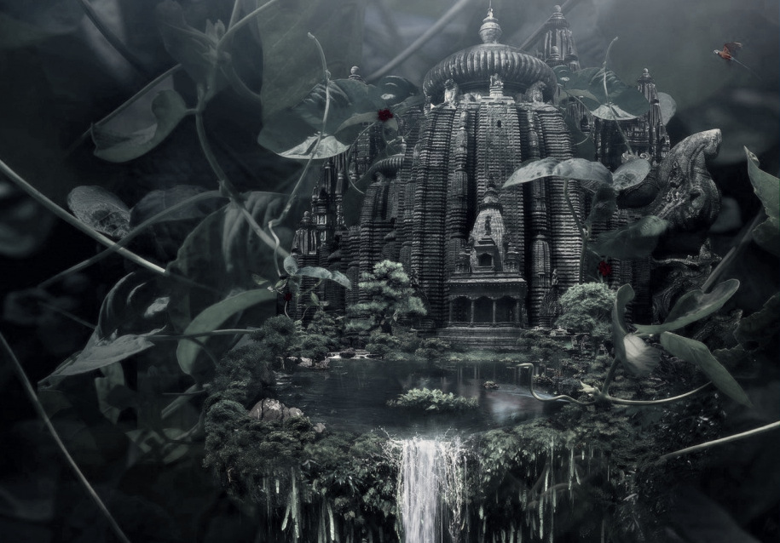
SHIT!!!
How this could happen 00:23:1,440:86,400 just a day remaining in my hand maybe the time when the queen had cursed my friends she had also cursed our watches. Ohh no if I have then my friends also have a day. Ohh **** how idiot I am its common sense when the queen dropped that pendant the pendant fall just into this shrub therefore of course the castle of time will be just right above this shrub. Up here in the sky but there must be a way I must search (Mark goes behind the temple and watches that there was an idol of a king) May be this is the idol of king Lolithon. Hey wait I have seen this face somewhere but I don’t remember let me check it out what’s this new thing.
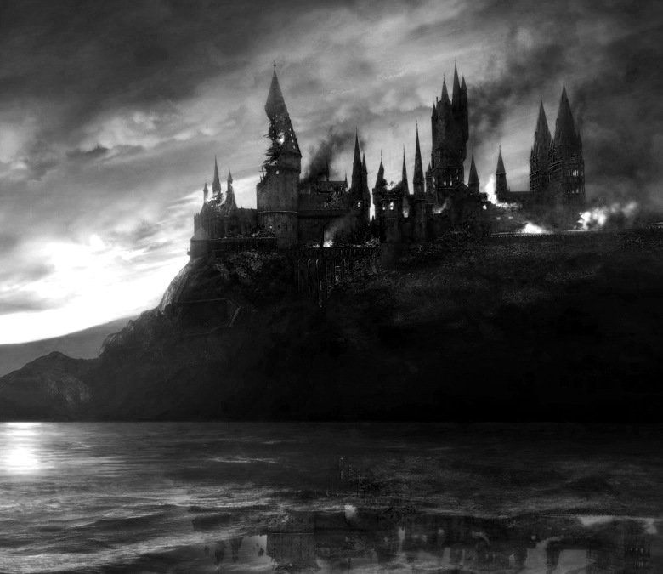
(Mark goes and touches that idol and the idol begins to shine brightly and a huge range of gold staircase enfolds from the idol Mark runs briskly from the staircase and thus reaches the entrance of the castle of time. There he finds a large variety of stunning flowers dancing in the dawn and alas he tone of his girlfriend crying for help. Mark felt tranquiled after hearing her voice. Perceived her at the top of the castle at the same moment the queen of time materialized.)
Ohh welcome back you the majestic queen of time. Now your time is going to get terminated by my own hands, said Mark. No you are wrong your time, love and life is in my hands, said the queen. There is nothing that can destroy the power of love and the wisdom of life not even you ugly queen. True love has special power packed bounds that can never be devastated, said Mark.

PART X -- attainment of an old unknown belovent.
(Alas the queen had begun a clash with Mark she cursed some perilous hexes on Mark but he blocked them successfully. As the queen went on getting more and angrier. Mark looked in her eyes and understood her problem.)
(Time – 00:1:60:3600)
There
is no reason to fight with me as there is a fixed time for everyone to die in this world and not even a queen like you can hiatus it. I have understood your problem and have a solution to it, said Mark. What solution I don’t want to hear your nonsense, said the queen. It’s not nonsense it’s about your belovent king Lolithon, said Mark. What about Lolithon??? What do you know about him??, said queen I know everything who was he and what do you felt about him. I know that you loved him a lot but due to some erroneous circumstances he expired. And as a result of his death to avenge it you made the heart clock. He is my grandfather yet I had never met him but I auspiciously reminisced his name his name is Sir Lolithon Samuel. There is nothing like caste and background status, social group and social order all these are made by people’s own beliefs. I know that the king died while resolving the problems of the religious castes but he didn’t want terror and awe given to his people he just felt that everyone should be doctored correspondingly but you are doing the anatomy of his works. There are two things in this world that are immortal i.e true love and wisdom. Others all are fake, said Mark.
(Impulsively Mark’s watch begin to ringing the voice barked countdown has been started. The time was – 00:00:1:00 just a minute left.)
Please if yet you haven’t comprehended my words you have left the king’s death in vague. This is the time to do something not for me, not for my girlfriend, not for the world but just for your true love bye Julie love you take care, said Mark. No Mark this can never happen hey listen you ugly shit queen if you have understood Mark’s words you would have saved his life but you are not doing anything this means that you never have true love on the king you are his grandmother do you want to kill your grandson due to this caste discourages, cried Julie. (10, 9, 8 said the watch) I can just increase the countdown by 5 minutes I can’t take back my spell, said the queen.
(The queen made some spells and as the 5 minutes returned to Mark’s and his friend’s life the heart clocks time began to rapidly move like a stop watch as the queen has casted and tried to take her spells back. The spell was taken back but she lost her powers and fell on the ground and was on the prone to die when she had a hug with Mark and said her last few dying words.)

PART XI -- BACK TO PAVALLION.
Ohh
grandmother please tell me how to stop this otherwise everything will be digested and finished by the heart clock, said Mark. The heart clock can be stopped by turning it into self-destruction mode it can be done by opening its midpoint and pressing the green button bye Mark. Mark clasped the hands of Julie and ran to the heart clock and just moved to its focus but there was a key hole.
(Mark thought a lot but he didn’t gasped anything time was running out. Alas Marks sight went on an envelope and he memorized the key that was in the envelope that he had received he briskly removed the key and opened the focus of the heart clock and clicked the green button. As he clicked it there were huge vibrations and the world altered and they both returned to the original place from where they had started.)
Thank god we are back, said Mark and Julie in relief. But Mark how did you get to know that he was your grandfather, said Julie. Mark replied, the book which I got on its first page it was written “owned by Sir Lolithon Samuel. Ohh said Julie and Ron. Hey Ron thank god you are alright, said Mark. Hey what happened to me I have saved you. Hahaha, both Mark and Julie laughed. Ok Ok you saved us Ron, said both Mark and Julie. I think Ron your mom would be finding you since a long time, said Julie. Ohh fish sorry friends need to go if you need my help please don’t hesitate to call me bye, said Ron.

PART XII -- PROLOGUE OF NEOTERIC AMBIGUITIES.
AAHA!!!
At last we are back to our house, said Mark. I love you Mark, said Julie. Mark also replied the same. (Both of them kissed and Julie went to her home.) Hey mom I am back sorry for taking a long time, said Mark. What long time??? It has been just 10 minutes that you have gone out. I just want to teach this boy how to read and the importance of usage of time, said Mark’s mother. Noooooo no more time tales please. Hey what’s this looks like a watch let me first go to my room. Hey what’s this red button?
(As Mark clicks the knob he hears the voice of his grandfather thanking him for saving the life of the people. Later he says please gash the last page of the book and read out. Mark tears the last page that was secretly sticken to the back hardcover. It was written that a new key to terrain lies beside the tomb of his grandfather. Mark quickly runs to the tomb of his grandfather and finds that a key has been stucken with a letter on his tombstone. He took the key and read the letter and read it out that son I am alive please save me I am in the protection of terror and in the death of immortality please save me.)
Coming soon grandfather but please don’t give such tough conundrums.

Next volume coming soon
Thank you for reading.
The end.

-----------------------------------------------------------------------------

